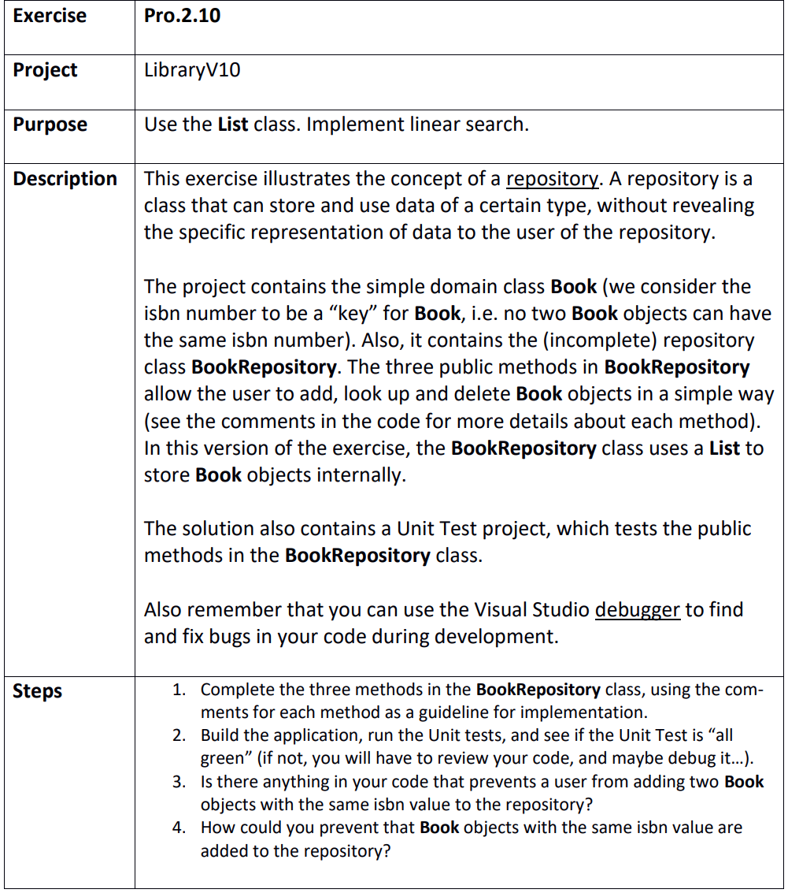

Step 1
LibraryV10.sln
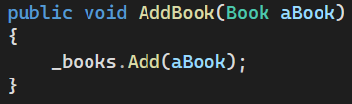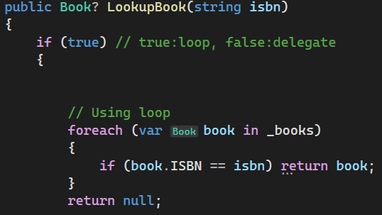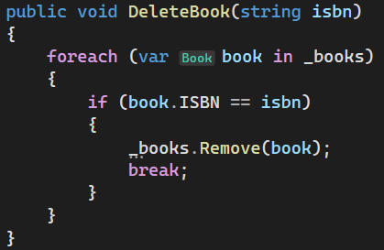

Step 2
All green first try ez fr fr

Step 3
Neigh

Step 4
By THROWING a goddam exception when they try to do it!
